Preface
Imagine having the power of an advanced AI—like ChatGPT—not in the cloud, but right on your own laptop. In an era dominated by tech giants offering AI services from centralized servers, a new frontier is emerging running AI models locally. This shift empowers individuals and small teams to reclaim control over their technology, driving innovation without relying on massive infrastructure.
“A Practical Guide to Ollama” is your gateway to this revolution, showing that you don’t need a supercomputer or expensive cloud services to unlock the vast potential of AI. With just your laptop and the right tools, you can run sophisticated models like LLaMA or Mistral, bringing real-world AI capabilities to your fingertips.
This journey isn’t just about convenience; it’s about freedom—freedom to experiment, innovate, and build without limits. Whether you’re a curious developer or a student in a dorm room, this guide equips you with the knowledge and resources to turn your ideas into reality. By blending technical insights with practical steps, this book demonstrates that the future of AI isn’t confined to large corporations; it’s increasingly available to anyone with the curiosity to learn.

Who is this book for
This book is for anyone curious about harnessing the power of AI on their own terms, without relying on expensive cloud-based services. Whether you're a seasoned developer, an aspiring entrepreneur, or a student taking their first steps into AI, this guide will help you navigate the exciting possibilities of running advanced models like LLaMA or Mistral locally. Here's who will benefit most:
- Software developers and engineers:
  - Looking to explore AI capabilities without depending on third-party platforms
  - Interested in experimenting with custom models for personal or professional projects.
  - Seeking cost-effective solutions to integrate AI into software or hardware applications.
- Students and Educators:
  - Eager to dive into AI and machine learning without the financial barriers of cloud services.
  - Wanting to explore practical applications of AI in a hands-on manner.
  - Looking for resources to teach or learn about running AI locally.
- AI/ML engineers:
  - Professionals seeking to deepen their understanding of running advanced models locally.
  - Engineers looking to optimize workflows by integrating on-device AI capabilities.
  - Developers aiming to experiment with fine-tuning and deploying custom models outside traditional cloud ecosystems.
- Technical founders/CTOs:
  - Startup founders and Chief Technology Officers (CTOs) wanting to explore AI-driven ideas while staying budget-conscious
  - Seeking to prototype, iterate, and build AI solutions
- Hobbyists and Tinkerers:
  - Tech enthusiasts eager to experiment with state-of-the-art AI technologies.
  - Curious individuals passionate about learning and creating in the AI domain.
- Organizations with Limited Resources:
  - Small businesses or nonprofits need affordable AI solutions.
  - Teams exploring AI implementations while keeping operational costs minimal.

What this book covers

Part 1: Foundations of AI and Ollama
Chapter 1, The LLM Landscape: Key Players and Core Concepts
Dive into the world of large language models (LLMs) by exploring the major players, including OpenAI, Meta's LLaMA, and Mistral. This chapter demystifies the core concepts of LLMs, explaining their architecture, training processes, and the transformative role they play across industries. Whether you’re a novice or an expert, gain insights into how these models are shaping the future of AI.
Chapter 2: Mastering Prompt Engineering Across Industries
Effective prompts are the key to unlocking an LLM’s full potential. This chapter provides a comprehensive guide to crafting precise and creative prompts tailored to different industries. Learn how to ask the right questions, structure your inputs, and get the most out of AI, whether you're in healthcare, finance, education, or entertainment.
Chapter 3: Running Ollama: CLI, API, and Fine-Tuning for Beginners and Experts
Discover how to set up and run Ollama models on your device, starting with the command-line interface (CLI) and APIs. This chapter walks you through step-by-step instructions for beginners and advanced tips for fine-tuning models, enabling you to create bespoke solutions for personal or professional use.

Part 2: Deep Dive into Ollama
Chapter 4: Ollama Tools and Integrations: Building Seamless AI Workflows
This chapter explores the suite of tools and integrations Ollama offers, designed to simplify AI workflows. From integrating with third-party applications to streamlining processes across diverse platforms, learn how to harness Ollama’s ecosystem to create seamless, efficient AI-driven solutions.
Chapter 5: The Core of Ollama: Key Features and Unique Strengths
Uncover the unique strengths that set Ollama apart from other AI platforms. From its local-first architecture to its lightweight, efficient design, this chapter provides an in-depth look at Ollama's standout features and how they cater to both individual users and enterprises.
Chapter 6: Enterprise with Ollama: Scaling AI for Businesses
Learn how Ollama supports scaling AI capabilities in a business context. This chapter discusses enterprise-specific features, including security, customization, and cost-efficient deployment strategies, making Ollama a valuable tool for organizations of all sizes.

Part 3: Applications and Vision
Chapter 7: CodeLlama: Enhancing Productivity with Ollama (30 pages)
Discover how developers can leverage CodeLlama, a specialized tool within Ollama, to enhance productivity and streamline coding tasks. From automating repetitive work to debugging and code completion, this chapter explores how Ollama empowers software engineers to do more with less effort.
Chapter 8: Leveraging Ollama Locally: Working with XLS, TXT, and Images (30 pages)
Explore Ollama's capabilities in handling various file types, from spreadsheets (XLS) to text documents (TXT) and images. This chapter provides practical workflows and examples, showcasing how to use Ollama locally for tasks like data analysis, content generation, and image processing.
Chapter 9: Running Ollama in the Cloud with GPU: Use Case TBD
Delve into the possibilities of running Ollama on cloud GPUs for scalable, high-performance applications. This chapter will present a compelling use case, demonstrating how Ollama can combine the power of local-first design with cloud-based resources for complex tasks.
Chapter 10: Future and Outlook: The Evolving Role of Ollama in AI
Conclude with a forward-looking perspective on Ollama’s potential in the AI ecosystem. Explore upcoming trends, challenges, and opportunities, and gain insights into how Ollama could continue to redefine accessibility and innovation in AI for years to come.

To get the most of this book
This book aims to provide you with a solid foundation on how to use Ollama. The AI landscape is experiencing a shift in paradigm. Ollama is an open-source software that empowers everyone to easily achieve hybrid or local AI setups and workflows.
This book will equip you with practical applications and use cases, making it an ideal resource for anyone who wants to gain a solid action plan and foundation in the new AI landscape and paradigm. To fully benefit from this book, some foundational knowledge will be helpful. While the book provides step-by-step instructions and explanation, having the following prerequisites will allow you to dive deeper into the concepts and make the most of the content:
- A basic understanding of AI/ML concepts (training datasets, evaluation metrics)
- A basic understanding of Python programming (running scripts, interacting with APIs)
- A basic understanding of the math behind neural networks (linear algebra, matrix operations, and optimization techniques)
- A general interest in natural language processing (NLP) (since many examples of this book revolve around LLMs and their applications in NLP, having a basic grasp of NLP tasks like text generation, summarization, and language understanding will be beneficial)

Conventions used
There are many conventions that will be used throughout the book

Side note: additional context or background information to enrich your understanding of the topic.

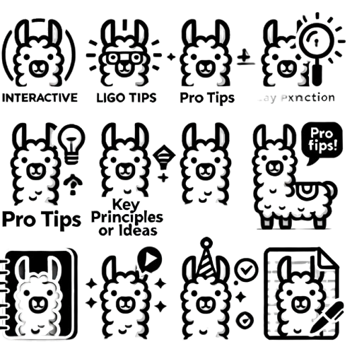
Key principle: a fundamental concept or takeaway that underpins the material being discussed.

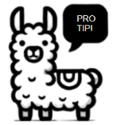
Pro Tip: Offers practical advice or a shortcut to help you work more efficiently or effectively.

Code Snippet: A small, functional piece of code to illustrate a concept or help you apply what you've learned.

Case Study: A real-world example that demonstrates the practical application of the concepts covered.

Inquiry or Quick Question: Poses a thought-provoking question to encourage reflection or deepen your understanding.
Check Your Learning: At the end of each chapter of section, this is an opportunity to review and reinforce key points through questions or exercises.

1

The LLM Landscape: Key Players and Core Concepts

Welcome to the Practical Guidebook to Ollama! In this book we will embark on an exciting journey into the world of advanced local AI. If you are an active large language model (LLM) user like me, I am sure that we all once had the thought and concern about privacy. Well, Ollama is leading a new era of innovation with it being a cornerstone piece of privacy-focused, agentic, and low-cost AI.
Over the past few years, we have witnessed the disruptive and transformative power of generative AI. ChatGPT, Bard, DALL-E, Gemini, just to name a few. These tools have amazed us in their ability to generate human-like and coherent responses on simple natural language prompts.
Despite the conversational prowess and immense potential, this is just the beginning. Large language models (LLMs) are not just text generators – they’re powerful reasoning engines capable of solving problems, automating tasks, and serving as the brains behind intelligent applications.
This book dives deep into Ollama, an open-source tool that allows you to run sophisticated AI models locally on your own machine. By exploring Ollama, we’ll uncover a future where AI is not just the domain of large corporations but available to anyone at their own privacy.

What is Generative AI?

Artificial Intelligence (AI) is a branch of computer science focused on building machines that can perform tasks that typically require human intelligence. These tasks include understanding natural language, recognizing objects in images, making decisions, and even learning from past experiences. At its core, AI enables machines to simulate human-like thinking and problem-solving. Whether it’s a virtual assistant responding to your voice commands or a recommendation system suggesting a movie, AI plays a crucial role in many modern applications. The field of AI is broad, covering areas such as machine learning—where systems learn patterns from data—and deep learning, which uses neural networks to tackle complex tasks like speech recognition and image classification.
Generative AI takes AI one step further by not only analyzing or recognizing data but also generating new content. Imagine a system that can write a poem, create a piece of artwork, or compose music just by learning from existing examples. That’s generative AI in action. It uses advanced models to produce entirely new outputs based on a given input. One of the most prominent applications of generative AI is large language models (LLMs), like GPT, which can generate human-like text based on a prompt. From writing articles to creating code, generative AI has rapidly expanded its influence across industries such as entertainment, marketing, and even healthcare, where it helps design new drugs or diagnose diseases.
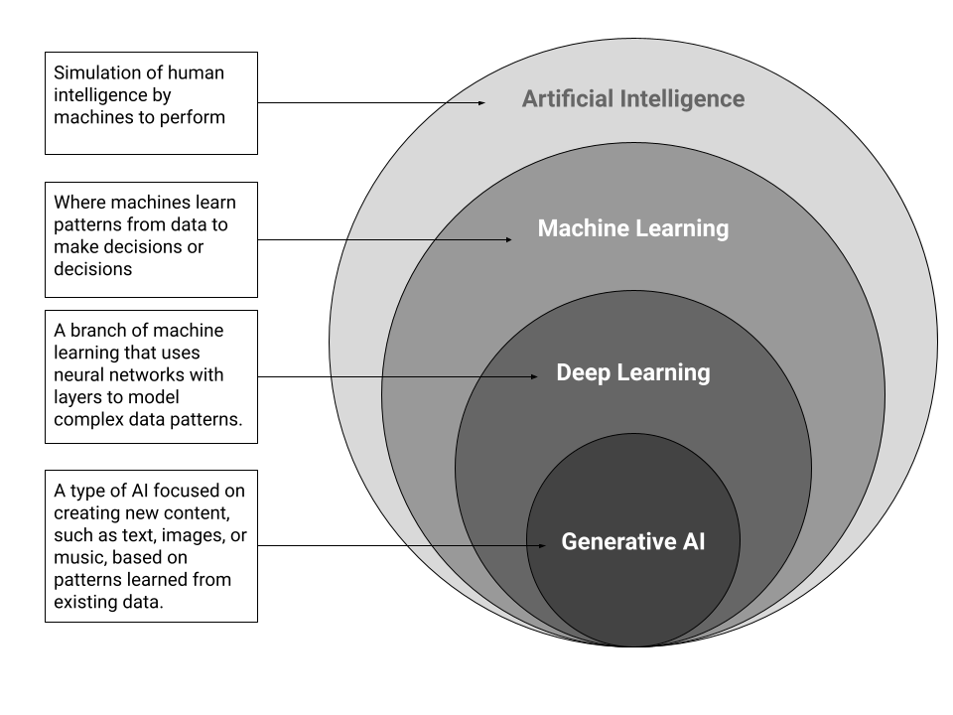

What is a language model?
At the heart of generative AI are language models, systems that enable machine learning models to understand and generate human language. By processing large amounts of data, language models form the backbone of generative AI, allowing it to produce meaningful and coherent responses.
Language models have evolved significantly, from statistical models like n-grams to neural-based models like recurrent neural networks (RNNs), but the most powerful ones today are based on Transformer models, which have revolutionized the field of natural language processing (NLP).
To fully grasp how these models work, we must dive into the architecture that makes them so powerful. This brings us to the concept of the Transformer, the underlying structure responsible for the breakthroughs in modern language processing and generation tasks.

Transformer Models
Transformer models are central to modern natural language processing (NLP). They have two main components: the encoder and the decoder. The encoder block processes the input text and creates a contextual understanding of it, which is useful in tasks like language translation, where understanding meaning is critical. The decoder block generates new text, making it essential for tasks like text generation, as seen in models like GPT. Together, these blocks enable transformers to handle a wide range of language tasks with impressive accuracy.
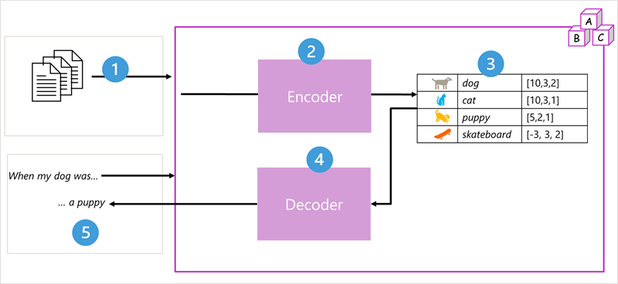
- The model is trained using large amounts of text, often from the internet.
- The text is broken into smaller parts (tokens), and the encoder looks at how these tokens relate to each other using attention.
- The encoder creates embeddings, which are vectors that represent the meaning of each token.
- The decoder uses these embeddings to predict the next word or phrase in a sequence.
- For example, given “When my dog was,” the model might predict the next word, like “a puppy”.
This design is foundational for large language models. The model is trained on large datasets, often sourced from the internet, and breaks text into tokens, such as individual words. The encoder processes these tokens using attention to understand their relationships, creating vectors called embeddings that represent the meaning of each token. The decoder then uses these embeddings to generate new, contextually relevant text. For instance, given the input “When my dog was,” the model analyzes the context to predict a suitable completion, like “a puppy,” using patterns from the training data.
In practice, transformer models can vary in their architecture. For example, Google’s BERT model, used for tasks like search, relies only on the encoder block, while OpenAI’s GPT model, which focuses on text generation, uses just the decoder block. Although a full exploration of transformers is beyond this chapter, understanding key components like the encoder and decoder helps explain how they enable tasks such as generating coherent language or interpreting complex text relationships, forming the foundation for generative AI systems.

Tokenization
The first step in training a transformer model is breaking down text into smaller pieces called tokens. Typically, each token represents a word, but tokens can also include subwords or punctuation. This flexibility improves the model’s ability to handle rare or misspelled words by splitting them into smaller, recognizable parts. For example, words like “skateboarding” can be tokenized into subwords like “skate” and “boarding,” allowing the model to better understand uncommon terms or handle typos efficiently.
For example, the sentence “I heard a dog bark loudly at a cat” can be tokenized like this:
- I (1)
- heard (2)
- a (3)
- dog (4)
- bark (5)
- loudly (6)
- at (7)
- a (3)
- cat (8)
The sentence is then represented as a sequence of token IDs: {1, 2, 3, 4, 5, 6, 7, 3, 8}. As more text is trained, new tokens are added to the vocabulary, resulting in thousands of tokens over time. Each new token gets an ID, forming a rich vocabulary the model can use to generate meaningful sequences of text.

Embeddings
Embeddings are used to capture the meaning and relationships between words that simple IDs can't provide. For example, search engines rely on embeddings to find content with similar meanings, even if different words are used. When you search for “best hiking trails,” embeddings help the engine find articles and websites with similar content, even if they don’t use the exact same words. By working in this multidimensional space, embeddings allow models to understand and generate human-like language.
Each element in the vector represents a dimension in a multi-dimensional space, with vectors that point in similar directions indicating words with similar meanings. For instance, the embeddings for “dog” and “puppy” will be very close in direction, showing their semantic connection, while a word like “skateboard” will have a vector pointing in a very different direction. This is how the model recognizes the meaning and context of words.
Cosine similarity, a mathematical technique, helps measure how similar two vectors are in terms of direction, regardless of distance, showing how semantically close words are to each other.
In practice, language models don’t work with just three-dimensional vectors but with many more dimensions. This allows them to capture complex relationships and nuances in meaning. There are several ways to generate these embeddings, such as using Word2Vec or the encoder block of a transformer model. These techniques help the model better understand the connections between words based on their context.
By working in this multidimensional space, embeddings allow models to generate human-like language that respects the relationships and meanings of words in a given context. This process is crucial for tasks like translation, summarization, and question-answering.


Attention
Think of attention layers like skimming a text. When skimming, your brain focuses on the most important words while ignoring less relevant ones. Similarly, the attention layers highlight key tokens in the input to understand context.

For example, when reading “I heard a dog bark,” the attention layer focuses on “dog” and “bark” to predict the next word.

In the encoder block, attention layers analyze each token and its surrounding tokens to assign meaningful vectors (or embeddings) that reflect these relationships. This contextual understanding allows the model to create token representations that vary depending on the context in which the token is used. For example, the word "bark" would have different embeddings in the two sentences mentioned above.
In the decoder block, attention layers predict the next token in a sequence by analyzing the tokens generated so far. The model evaluates the importance of previous tokens in determining the next token. For instance, given the partial sequence "I heard a dog," the attention layer will assign more weight to the words “heard” and “dog” to predict the next word, which might be "bark."
The attention layer doesn’t directly process the words themselves; instead, it works with their numeric vector representations. Each token is represented by a multi-dimensional vector, and the attention mechanism assigns weights to these vectors based on their relevance to the other tokens. For example, if a sequence of tokens represents “I heard a dog,” each token would have an embedding like:
- [1, 5, 6, 2] (for "I")
- [2, 9, 3, 1] (for "heard")
- [3, 1, 1, 2] (for "a")
- [4, 10, 3, 2] (for "dog")
The goal is to predict the next token’s vector using the information from the previous tokens. The attention layer assigns a numeric weight to each token to calculate an attention score, which helps in predicting the next token. In practice, transformers use a method called *multi-head attention*, which involves calculating multiple attention scores by looking at different aspects of the token embeddings. These multiple scores are then combined by a neural network to identify the most probable next token in the sequence.
This process continues step by step for each token, with the model using the generated sequence so far as input for predicting the next token. The model builds the output sequence one token at a time, allowing it to generate coherent text that makes sense based on the input context.
By using attention layers in both the encoder and decoder, transformer models excel at tasks like machine translation, text generation, and more, as they can weigh the importance of different words in a sentence and generate accurate, context-sensitive outputs.
The following animation gives a simplified overview of how the attention mechanism operates. The calculations within the attention layer are more intricate, but the basic idea can be demonstrated with this simplified example.
What this all means is that a transformer model like GPT-4, which powers ChatGPT, is built to take a text input (called a prompt) and generate a grammatically correct output (called a completion). The model’s “magic” lies in its ability to create coherent sentences, not because it “understands” or has “intelligence,” but due to its massive training on data from the internet and its complex structure. This allows GPT-4 to produce human-like responses by recognizing patterns and relationships between words in its training data.

Popular Language Models and Providers

A Brief History of OpenAI and ChatGPT

OpenAI’s Founding and Early Days
OpenAI was founded in December 2015 as an artificial intelligence research lab, with Elon Musk, Sam Altman, Greg Brockman, and others leading the initiative. Its mission: to develop AGI (Artificial General Intelligence) in a way that benefits humanity. OpenAI was established as a non-profit with a strong focus on openness, hence the name, to ensure AI advancements were shared widely for societal benefit, rather than monopolized.

GPT and the Start of Language Model Research
OpenAI’s first breakthrough came with the development of the Generative Pretrained Transformer (GPT) model. Introduced in June 2018, GPT-1 was a proof of concept that demonstrated how large-scale unsupervised learning on internet text could generate coherent sentences and perform various NLP (Natural Language Processing) tasks. However, its impact was limited to research communities.
The real game changer was GPT-2, launched in February 2019. It shocked the AI community due to its ability to generate human-like text and tackle a wide range of language tasks without task-specific training. OpenAI initially refrained from releasing GPT-2’s full version, citing concerns over misuse, such as creating disinformation at scale. Eventually, the full model was released after OpenAI’s risk analysis showed limited evidence of misuse.

GPT-3: The Breakthrough
The release of GPT-3 in June 2020 marked a watershed moment in AI. With 175 billion parameters, it was by far the largest and most capable language model at the time. GPT-3 could write essays, generate code, answer questions, and even engage in detailed conversations. Its versatility sparked widespread interest in applications ranging from content generation to customer service chatbots. This also set the stage for what would become one of OpenAI’s most significant innovations: ChatGPT.

The Birth of ChatGPT
ChatGPT, introduced in November 2022, was a fine-tuned variant of GPT-3, specifically optimized for conversational tasks. While GPT-3 was designed to perform many different types of language tasks, ChatGPT focused entirely on dialogue. This made it particularly adept at engaging users in human-like conversations, explaining concepts, writing creatively, and assisting with various tasks.
One breakthrough with ChatGPT was the implementation of Reinforcement Learning from Human Feedback (RLHF). This technique allowed OpenAI to fine-tune the model by incorporating human feedback to improve responses, making interactions more aligned with user preferences. As a result, ChatGPT became one of the most successful and widely used AI products, appealing to both casual users and professionals alike.

GPT-4 and the Evolution of ChatGPT
In March 2023, OpenAI released GPT-4, a multimodal model that accepted both text and image inputs. GPT-4 was an even more powerful iteration, designed to handle more nuanced prompts and generate more complex outputs. This version of ChatGPT solidified OpenAI’s reputation as the leader in conversational AI, with the model being used in everything from customer support systems to content creation and technical writing.

OpenAI’s Impact and the Future of ChatGPT
Since the release of ChatGPT, OpenAI has made significant strides in integrating the model into real-world applications. Microsoft, a key partner and investor in OpenAI, embedded ChatGPT technology into its products, including Microsoft Word and Excel, under the brand Copilot. ChatGPT itself has also evolved into a versatile tool used in education, software development, customer service, and beyond.

Looking forward, OpenAI continues to push the boundaries of what’s possible with AI while grappling with ethical concerns. The organization shifted from its purely non-profit origins to a “capped profit” model with the formation of OpenAI LP, allowing it to raise substantial capital for continued research while still adhering to its mission of developing safe and beneficial AI.
As ChatGPT evolves, it is not just a model, but a symbol of the broader potential and challenges posed by generative AI. It showcases how AI can augment human productivity while raising important questions about the future of work, ethics, and safety in AI development.

Popular LLM Providers
1. OpenAI and Microsoft Partnership
OpenAI, the creator of ChatGPT, has maintained a strategic partnership with Microsoft since 2019. Microsoft has invested heavily in OpenAI, totaling billions of dollars, and in return, OpenAI’s cutting-edge language models, such as GPT-3 and GPT-4, power Microsoft’s product suite. The integration is most prominent in Microsoft’s Copilot feature within tools like Word and Excel, which helps users by generating content, summarizing information, and even automating workflows.
Microsoft also provides infrastructure for OpenAI’s models via its cloud platform Azure, allowing businesses to leverage LLMs at scale. This partnership underscores Microsoft’s aim to establish itself as a leader in the enterprise AI space, catering to business solutions, software development, and even cloud-based LLM APIs.

In summary, OpenAI and Microsoft offer a powerful combination of cutting-edge LLMs paired with strong enterprise integration capabilities, making them a top choice for businesses looking to implement generative AI at scale.

2. Google (DeepMind and Bard)
Google has long been a dominant force in AI research, and their contributions to the LLM space are significant. Google’s BERT (Bidirectional Encoder Representations from Transformers), introduced in 2018, revolutionized the field by allowing models to understand context from both sides of a word in a sentence. BERT was followed by other models like T5 and PaLM, both aimed at improving text generation, translation, and summarization.
In 2023, Google unveiled Gemini, part of its DeepMind research branch, which integrates advances in LLM architecture with its existing capabilities in AI research. Google has integrated AI into its flagship products such as Google Search, Google Docs, and Gmail under the brand Bard. These models provide real-time, context-aware responses, making them valuable tools for productivity and knowledge management.
Google’s robust research infrastructure, including TensorFlow and TPUs (Tensor Processing Units), makes its models highly accessible to developers and researchers. Google’s ecosystem, from enterprise tools to open-source models, provides flexibility and scalability, cementing its place as a strong contender in the AI space.
3. Meta and the Rise of Open-Source LLMs
Meta (formerly Facebook) entered the LLM race with the release of the LLaMA (Large Language Model Meta AI) series. Unlike closed models like GPT-4, LLaMA is open-source, allowing developers to use, modify, and fine-tune the model for their own purposes. Meta’s mission with LLaMA is to democratize AI, making powerful LLMs accessible to a broader audience, particularly in academia and research.
LLaMA has been pivotal in providing cost-effective solutions, as its smaller models (e.g., LLaMA-7B and LLaMA-13B) perform comparably to larger models like GPT-3, but with lower resource requirements. This has opened the door for startups, researchers, and independent developers to deploy AI solutions without the heavy computational costs typically associated with LLMs.
Meta’s commitment to open-source AI stands in contrast to the more guarded approaches of OpenAI and Google. As AI continues to evolve, Meta’s open-source LLMs offer flexibility and the potential for rapid innovation through community contributions.
4. Anthropic: AI with a Safety-First Approach
Anthropic, founded by former OpenAI researchers, entered the LLM space with a focus on AI safety and ethical considerations. The company’s key goal is to develop LLMs that are less likely to produce harmful outputs and more aligned with human values. Anthropic’s flagship model, Claude, is designed to be a safer alternative to traditional LLMs like GPT-3 and GPT-4.
Claude places a greater emphasis on alignment techniques, aiming to minimize the risk of AI systems generating biased, harmful, or dangerous content. The company’s research focuses on creating AI systems that are transparent, interpretable, and capable of safely assisting with a wide range of tasks.
Anthropic’s safety-first philosophy is resonating in sectors such as healthcare, finance, and government, where the consequences of AI mistakes can be severe. While the company is newer to the scene, its emphasis on safety and alignment positions it as a key player in the evolving landscape of AI ethics and responsible AI development.

5. Mistral: A New Player in the LLM Race
Founded by former researchers from Google and Meta, Mistral is a newer entrant in the LLM space, aiming to provide state-of-the-art models that are optimized for both performance and efficiency. While the company is still in its early stages, it has quickly garnered attention for its potential to challenge the major incumbents.
Mistral focuses on multimodal models, which can process both text and images, similar to OpenAI’s GPT-4. Its goal is to push the boundaries of AI by offering models that balance performance with resource efficiency, making them more accessible to businesses and developers looking to deploy AI without exorbitant costs.
Despite being a relatively young company, Mistral is gaining traction as a key player, thanks to its innovative approach and the expertise of its founding team. The company’s focus on efficient AI solutions makes it a promising competitor to watch in the LLM ecosystem.

6. Hugging Face: The Community-Driven AI Platform
Hugging Face has become the go-to platform for open-source AI models and libraries, especially for LLMs. The platform initially started with a focus on natural language processing but quickly evolved into a central hub for hosting models, datasets, and tools for the broader AI community. Hugging Face is best known for its Transformers library, which makes it easy for developers to fine-tune and deploy models like GPT, BERT, and LLaMA.
What sets Hugging Face apart is its community-driven model, where developers, researchers, and businesses can collaborate, share models, and contribute to the growing repository of AI tools. Hugging Face also offers Inference API services, allowing companies to integrate LLMs into their applications without needing to worry about infrastructure or scaling.

The platform’s commitment to open collaboration has made it a favorite among researchers and businesses alike, offering flexibility, cost-effectiveness, and a growing repository of AI models that can be deployed and customized with ease.

7. Ollama: Local Deployment of Language Models
Ollama is a rising player in the LLM space, distinguishing itself by focusing on local deployment of large and small language models (LLMs and SLMs). This is why we dedicated a book to help you explore this tool. Unlike cloud-based providers like OpenAI, Google, and Hugging Face, Ollama allows developers and businesses to run LLMs directly on local machines, giving them greater control over their data, privacy, and computational resources.
Ollama’s core offering is a command-line interface (CLI), which we will talk about later on, that simplifies the process of running models on local hardware. It has gained popularity for enabling small language models to operate efficiently on consumer-grade hardware, making it a great option for developers who want to avoid the complexities of cloud infrastructure. With the rise of privacy concerns and data sovereignty issues, Ollama’s focus on local deployment has gained traction, particularly in industries like healthcare, finance, and law, where sensitive data handling is paramount.

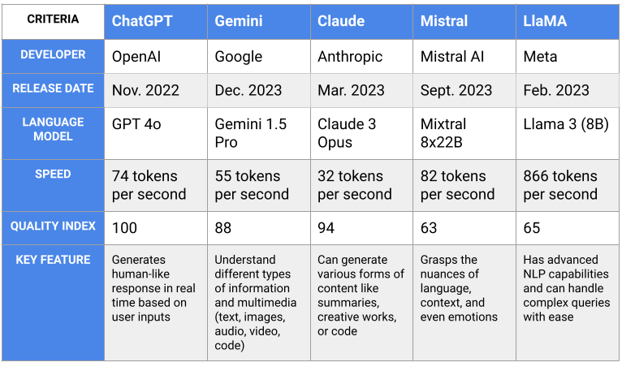

LLM vs SLM (Large and Small Language Models)
This is perhaps the most common question that anyone may ask nowadays regarding AI.
Language models can be broadly classified into two categories: Large Language Models (LLMs) and Small Language Models (SLMs). Each type serves different use cases based on computational requirements, resource availability, and specific application needs. However, the key difference between the two is primarily based on the size of their training data, domain specificity, and of course, their size! Many AI experts today even throw in the metric of performance to decipher the two types.

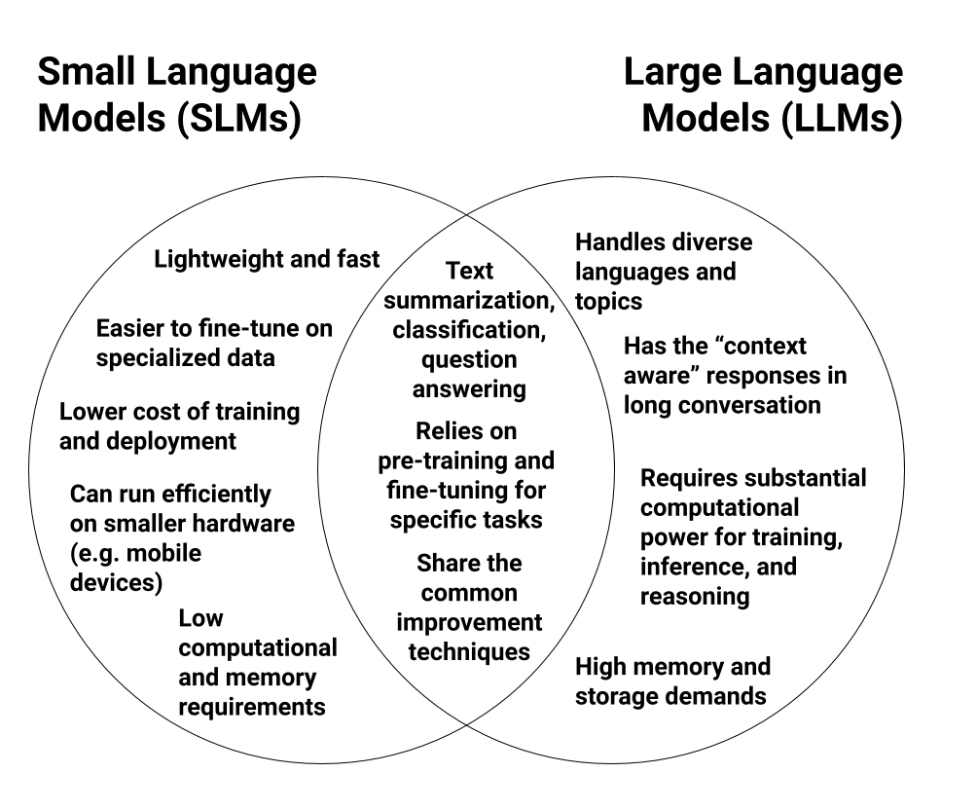
Key Principle
Context-aware responses
Inferencing
Reasoning
Common language model improvement techniques:
- Transfer learning:
- Knowledge distillation:
- Dataset curation:

Popular Language Model Application
For the most popular apps aside from ChatGPT, Microsoft Copilot should be on the list. Microsoft 365 Copilot is an AI-powered assistant integrated across various Microsoft tools, including Word, Excel, PowerPoint, Outlook, and Power Automate, to significantly enhance productivity and collaboration. Here’s a summary of how Copilot works within these platforms

This is eomt

1. Word: Copilot can draft documents, reports, and proposals based on minimal input or prompts. It assists with structuring content, generating ideas, and improving writing quality, helping users quickly produce high-quality documents.
2. Excel: In Excel, Copilot automates complex data analysis, such as generating pivot tables, summarizing data insights, and creating visualizations like charts, which speeds up tasks that traditionally required manual intervention and technical expertise.
3. PowerPoint: Copilot helps users convert Word documents or ideas into polished presentations. It automates the creation of slides, designs, and layouts, using the information provided, ensuring a consistent, professional output.
4. Outlook: Users can utilize Copilot to draft and summarize emails, ensuring clear and professional communication. It also helps users prioritize inbox tasks by suggesting replies or summarizing lengthy email threads.
5. Power Automate: Through Copilot, users can automate workflows by setting up data-driven triggers and actions without deep technical knowledge, boosting organizational efficiency.
Overall, Copilot improves productivity by automating repetitive tasks and offering AI-driven insights across Microsoft 365 applications, saving users time and effort. This integration allows businesses to harness generative AI across their everyday tools, leading to higher creativity, efficiency, and enhanced data-driven decision-making.
Microsoft Copilot can help with document creation, email summarization, and workflow automation, while GitHub Copilot can help with coding tasks like code completions, answering coding questions, and code refactoring.
Check your knowledge
- Question 1
- Question 2
- Question 3
- Question 4
- Question 5

Answers
- Question 1
- Question 2
- Question 3
- Question 4
- Question 5

Getting started with Ollama
Open-Source Models: A Foundation for Local AI
Open-source models have transformed the AI landscape by making advanced machine learning tools accessible to everyone, regardless of budget or infrastructure. These models, freely available to the public, allow developers to experiment, customize, and innovate without the constraints of proprietary systems. Small companies and research teams, in particular, benefit from running open-source models locally, as they can maintain full control over their workflows and prioritize data privacy without incurring high costs associated with cloud services.

Real-World Benefits of Open-Source Models
- Privacy-Focused Development: For industries such as healthcare and finance, where data privacy is paramount, open-source models allow for AI development and experimentation without sharing sensitive information with third-party services. For example, a small health-tech startup developing an AI diagnostic tool can use local open-source models to process patient data securely. This ensures compliance with strict regulations like HIPAA in the U.S. or GDPR in Europe, all while avoiding the need for expensive cloud-based solutions.

- Resource-Efficient AI Development: Many startups and academic research teams operate with limited budgets and resources. Open-source models are a perfect fit for these groups, as they can run AI models locally on modest hardware. Take, for example, a university research team studying climate change models: using an open-source language model like LLaMA locally allows them to iterate on AI experiments without incurring recurring costs from API usage. This type of flexibility fosters innovation and allows for the development of novel solutions in resource-constrained environments.

- Transparency and Customization: One of the most significant advantages of open-source models is their transparency. Because the underlying code and architecture are publicly available, developers can inspect, modify, and optimize models to meet specific requirements. A good example comes from the legal tech space, where companies developing AI-driven contract analysis tools have used open-source models to fine-tune their systems for local legal jurisdictions. This level of customization wouldn’t be possible with closed-source or proprietary models, which often limit a developer’s ability to adapt models to their unique needs.

- Reducing Costs for Long-Term Projects: Large enterprises and small teams alike can drastically reduce costs by switching from commercial APIs to local open-source models. For example, a media company that frequently generates summaries or analyses of news articles can use models like Phi-3 Mini to handle high-volume text generation tasks without paying per API call, ultimately saving significant sums over time.

Summary of Key Benefits
In summary, open-source models offer significant advantages in terms of flexibility, cost-efficiency, and transparency. By running models locally, companies and research teams can:
- Maintain full control over their data, ensuring privacy and regulatory compliance.
- Customize models to fit specific needs, from legal analysis to climate research.
- Save on ongoing operational costs by avoiding commercial API usage.

As open-source initiatives like Hugging Face and Meta’s LLaMA continue to expand, the potential for innovative and impactful AI applications will only grow. With platforms like Ollama streamlining the process of running these models locally, the future of AI development is more accessible than ever.

Install and Setup Ollama
Getting started with Ollama is simple, but following these steps carefully will ensure a smooth installation.
Step 1: Visit the Ollama Website
Navigate to the official Ollama website at [https://ollama.com/].
Download the appropriate installer for your operating system (macOS, Linux, or Windows).
Step 2: Download and Install Ollama
- macOS: After downloading, if you receive a warning that the developer cannot be verified, follow these steps:
- Go to System Preferences > Security & Privacy.
- Click Allow next to the blocked installation.
- Linux: Open a terminal and use the following commands to install Ollama:
chmod +x ollama-installer.sh
./ollama-installer.sh

- Windows: Double-click the downloaded installer and follow the prompts. If you encounter an issue with environment variables, ensure the installation directory is added to the system’s PATH. To do this:
- Right-click This PC and select Properties.
- Click on Advanced system settings, then Environment Variables.
- Add Ollama’s installation path to the Path variable.
Step 3: Verify Your Installation
Open a terminal or Command Prompt and type the following to confirm your installation:
ollama --version

You should see something like:
ollama version 0.3.13
ollama version is 0.3.13

Troubleshooting Common Issues
- Linux Permission Issues: If you get a permission error, use sudo to run the installer:
sudo ./ollama-installer.sh

- macOS Security Block: If you see a security block, go to System Preferences > Security & Privacy and click Open Anyway.
- Windows PATH Issues: If ollama is not recognized after installation, manually add the installation folder to the system’s PATH.

Explore Ollama Models
Ollama provides a wide range of powerful open-source models tailored for various use cases. Whether you need a lightweight model for quick text generation or a large-scale model for in-depth content analysis, there’s an option for every scenario. In this section, we’ll compare key models available in Ollama, highlighting their parameter count, best use cases, performance, and resource requirements to help you choose the right one for your project.

Model Comparison Guide
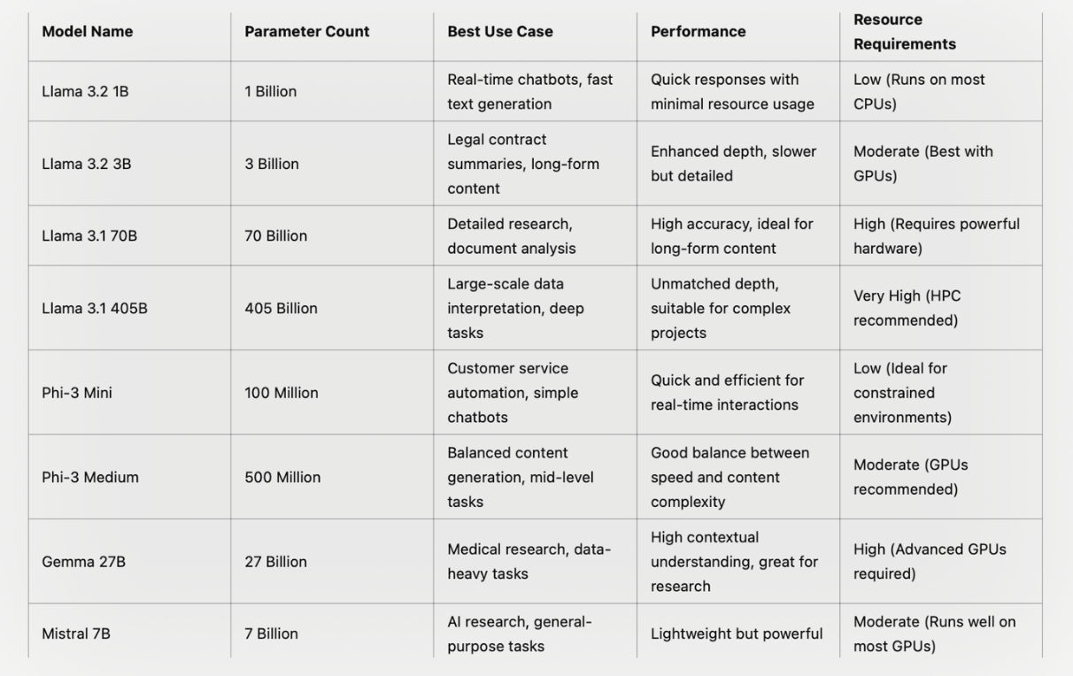
<< may need redraw this table >>
Practical Examples for Model Use
To give you a clearer sense of when to choose a particular model, here are some practical examples of real-world applications:
Llama 3.2 1B:
If you’re building a real-time chatbot that responds instantly to user queries, Llama 1B is ideal. For example, an e-commerce platform could use this model to handle customer queries about product availability or shipping details, where quick, concise responses are essential.
Llama 3.2 3B:
For more complex tasks like generating legal contract summaries, Llama 3B provides a balance between computational power and content depth. Law firms, for instance, can use this model to automate the summarization of lengthy contracts, saving time and resources while ensuring legal accuracy.
Llama 3.1 70B:
When working on projects that demand detailed analysis and research reports, such as generating a market analysis report for a financial firm, Llama 70B is the go-to model. Its ability to generate in-depth, coherent narratives makes it ideal for use in high-stakes environments.
Llama 3.1 405B:
This model excels in large-scale data interpretation, such as when processing and summarizing scientific datasets. For example, a research team analyzing global climate change data could use Llama 405B to generate nuanced insights from thousands of pages of scientific reports.
Phi-3 Mini:
Real-time interaction is where the Phi-3 Mini shines. It is perfect for use in customer service automation—for instance, a bank might employ this model in a chatbot that handles everyday customer queries, offering fast responses without overwhelming computational demands.
Phi-3 Medium:
If you need a good balance between speed and contextual understanding, Phi-3 Medium works well for mid-level content generation. Consider a publishing company using it to generate summaries for news articles, ensuring quick generation without sacrificing content quality.
Gemma 27B:
This model is great for tasks requiring a deep understanding of context and data. A medical research institution could leverage Gemma 27B to analyze large sets of clinical trial data, helping researchers generate accurate, detailed reports for pharmaceutical studies.
Mistral 7B:
For more general-purpose use, Mistral 7B is lightweight yet powerful enough for most AI research tasks. Whether you’re exploring natural language processing or building new AI applications, this model delivers strong performance without the need for overly complex setups.

Choosing the Right Model for Your Project
Choosing the right model comes down to balancing performance and resource availability with your project’s needs. For everyday tasks like text summarization, a smaller model like Llama 3.2 1B or Phi-3 Mini may be sufficient. But for high-stakes projects requiring in-depth analysis or long-form content generation, a model from the Llama 3.1 series or Gemma 27B would be more suitable.

Multimodal and Code Models: Expanding AI Capabilities
In addition to traditional language models, Ollama offers specialized models such as LLaVA (Language + Vision) and Code Llama, which cater to unique use cases involving multimodal data and coding tasks, respectively. These models enhance the functionality of AI by integrating different input types, such as text and images, or by assisting in the generation and debugging of code.

Real-World Use Cases for LLaVA
LLaVA is designed to handle multimodal tasks, where it processes both text and visual data, making it ideal for applications requiring both image understanding and text generation. Below are a few practical scenarios where LLaVA shines:
E-commerce Platforms: LLaVA can be employed in product recommendation systems that require both visual recognition and language processing. For instance, in an online store, LLaVA can analyze customer-uploaded images to recommend similar products. When a user uploads a photo of a shirt they like, the model can scan the store’s database for visually similar items and generate a description like, “This shirt is available in blue, red, and black with cotton fabric.”
Content Moderation: Platforms with user-generated content, like social media, can use LLaVA to automatically detect inappropriate images combined with harmful text. For example, the model can flag and remove posts that violate community guidelines by analyzing both image content and accompanying captions.
Medical Imaging: In healthcare, LLaVA can be integrated into tools that assist doctors in analyzing medical images (e.g., X-rays, CT scans) and generating corresponding diagnostic summaries. For example, the model might generate a report such as, “The CT scan shows mild swelling in the frontal lobe, consistent with recent trauma.”

Example Output for LLaVA in E-commerce:
Input: Image of a red shirt with a white logo.
Model Output:
“This is a cotton shirt available in red with a white logo. Similar products include a black shirt with the same design or a blue shirt with a smaller logo. Prices start at $29.99.”

Real-World Use Cases for Code Llama
Code Llama is tailored for code-related tasks, making it an invaluable tool for developers and programmers. It assists in generating, debugging, and optimizing code in multiple programming languages. Here are a few real-world scenarios where Code Llama is a game-changer:
Hackathons and Coding Competitions: During hackathons, developers are often pressed for time to write and debug code. Code Llama can assist by generating boilerplate code, providing quick fixes for common coding issues, or even debugging existing code. For instance, if a developer runs into an error while building a web application, Code Llama can suggest fixes or generate alternative code solutions.
Integrated Development Environments (IDEs): Code Llama can be embedded into popular IDEs like VS Code to offer real-time suggestions and error detection as developers write code. This can dramatically speed up the coding process, especially in large projects where manually reviewing code can be time-consuming.

Automated Code Reviews: Large software projects require thorough code reviews to ensure quality. Code Llama can assist teams by scanning through massive codebases to detect inefficiencies, security vulnerabilities, or coding style violations, ensuring that code quality standards are maintained across the board.
Pro Tip: Code Llama Debugging (example)
Input: Python code with an error in a function:
def add_numbers(a, b):
return a + b
print(“Sum:”, a + b)
Model Output:
“The print statement will never be executed because it is placed after the return statement. Consider moving the print statement above the return statement.”
Suggested fix:
def add_numbers(a, b):
print(“Sum:”, a + b)
return a + b

Summary and Practical Insights
Both LLaVA and Code Llama offer significant improvements in specialized AI tasks. LLaVA’s ability to process multimodal inputs makes it highly valuable for industries like e-commerce, content moderation, and healthcare, while Code Llama streamlines the coding experience for developers, enhancing productivity in hackathons, code reviews, and daily development workflows.
These models not only extend the capabilities of AI but also offer practical, real-world solutions that simplify complex tasks. The ability to generate relevant outputs in both text and code provides users with powerful tools for improving efficiency and accuracy in their projects.
Check your knowledge
- Question 1
- Question 2
- Question 3
- Question 4
- Question 5

Answers
- Question 1
- Question 2
- Question 3
- Question 4
- Question 5

2
Mastering Prompt Engineering Across Industries
“An expert knows all the answers if you ask he right questions”
- Claude Levi-Strauss
With the widespread and accessibility of language models from small to large, you have an expert at your disposal. However, in order to elicit the response you want, you need to ask the right questions.
AI applications like chatbots, media generation output data based on the structure, content, and sentiment of the input. Prompt engineering is a new field and emerging field which is crafting effective inputs (prompts) to guide a model to generate desired and relevant outputs.
Effective prompts optimize the results to align with your needs.
They are like chefs following a recipe to a meal you want, and by sending different prompts yield different results. The key lies in the questions and instructions you assign.
- Simple prompt: “Cook dinner” → the chef may make anything—spaghetti, sushi, salad, steak, etc.
- Better prompt: “Cook a spaghetti dinner” → now the chef has a clearer idea of what you want, but still has room for confusion. Have meatballs? What kind of sauce? Vegetarian?
- Effective prompt: “Cook a spaghetti dinner with marinara sauce, ground beef, and a side salad with Italian dressing” → Now the chef knows exactly what to prepare and can deliver the meal much closer to what you have imagined
The worst thing is having an expert at your disposal and not being able to elicit a response you desire. Get rid of the AI frustration and master the art of asking the right questions!
Key Principle
prompt: an input which produces the desired output
Language models cannot think critically like us, humans. Treat them as an employee who is working for you.
Clear instructions → Effective results
Vague instructions → Uneffective results

Keys to an Effective Prompt
️ Understand Your Objective | Clearly define what you want to achieve with your prompt. Is it information, creativity, or problem-solving?
️ Keep It Clear and Concise | Avoid overly complex or vague prompts. Clarity leads to better AI responses.
️ Context! Context! Context! | Provide enough background for the AI to understand the scenario but avoid unnecessary information
️ Experiment and Iterate | Don’t hesitate to refine your prompts based on the responses you get. Iteration is key to finding the most effective wording.
️ Consider Your Audience | Tailor your prompt based on who will interact with or benefit from the AI’s response.
️ Evaluate and Adapt | Continuously assess the effectiveness of your prompts and be ready to adapt as needed.

Even though these keys may sound vague and obvious, we will go more in depth on how to craft a highly effective prompt shortly.
If you think back about the prompt about the spaghetti, and it makes you hungry, its time to feed yourself a “yummy” framework to craft a prompt.
- C – Clarity: Be clear about what you want. No room for confusion, just like a clean, crisp morning.
- R – Role-play: Give the AI a role or persona. Think of the AI putting on a costume like an actor to fit the role you've assigned—whether it’s a teacher, a scientist, or a poet.
- I – Intent: Focus on your intent behind the prompt. What’s the purpose or result you’re after? The clearer your goal, the better the response.
- S – Specificity: The more specific you are, the more detailed the AI’s response will be. Instead of asking for “a snack,” ask for “a spicy burrito with extra guacamole!”
- P – Precision: Be precise with your words—no vague or fluffy instructions! Precision leads to more accurate outputs.
Pro Tip
Understand the model’s capabilities, constraints, and strengths. Different models were trained and specialized to do different tasks effectively. Therefore, giving the same prompt to different language models will elicit different results. Always choose the model that aligns with your use case.
A highly effective prompt (example)
Insert example here

Evaluation Metrics of Large Language Models (LLMs)
Despite the excitement surrounding LLMs, it is equally important to be conscious about the risks and potential effects it has. Therefore, mathematical metrics are routinely used on large language models to test its ability and minimize the risks of using it.
1. ROUGE (Recall-Oriented Understudy for Gisting Evaluation)
Rouge is primarily used for comparing a computer-generated summary of text with a reference (i.e. human-generated) summary. Rouge is mostly used for evaluating text-summarization tasks. The value of Rouges metrics ranges from 0 to 1.
1 is the highest score, indicating that model-generated summary and reference summary has a high similarity.
0 is the lowest score, indicating that model-generated summary and reference summary has little to no similarity.
ROUGE-1:
You look at one word at a time from two sentences and see how many words match. If a word appears in both sentences, you get a point.
For example:
- Sentence 1: "The cat is cute."
- Sentence 2: "That cat is fluffy."
You compare:
- "The" vs. "That" (no match)
- "cat" vs. "cat" (match!)
- "is" vs. "is" (match!)
- "cute" vs. "fluffy" (no match)
You got two matching words ("cat" and "is"), so ROUGE-1 is a score based on how many single words match.
ROUGE-2:
Now, you look at two words at a time from each sentence and check for matching pairs.
For the same example:
- Sentence 1: "The cat" vs. "That cat" (no match)
- "cat is" vs. "cat is" (match!)
- "is cute" vs. "is fluffy" (no match)
Here, only one pair ("cat is") matches. So ROUGE-2 looks at how many pairs of words match.
ROUGE-N:

Rouge-1, Rouge-2, Rouge-3… it can go on until Rouge-N

N represents the number of words you look at once.

In this case, N is the largest subsequence that can exist.

You look at N words at a time from the model-generated response and the reference which is typically human-generated. Afterwards, it sees how many words match. If a word appears in both sentences, you get a point.
2. BLEU (Bilingual Evaluation Understudy)
BLEU is often used in machine translation to measure precision it compares the overlap between the generated output and a reference output by looking at the precision of n-grams.
Limitation: It can penalize longer outputs because it rewards shorter, exact matches.
Example:
Real sentence: "The cat is cute." Your guess: "The cat is fluffy and cute."
Single words: You match "The," "cat," "is," and "cute." (Good job!)
Word pairs: "The cat," "cat is," and "is cute" match. (More points!)
Too long: But you added "fluffy and," which doesn’t match, so you lose a few points for that.
Score Range: 0 to 1, with higher scores indicating more overlap with reference text.
3. METEOR (Metric for Evaluation of Translation with Explicit ORdering)
A similar metric to ROUGE and BLEU, but it’s even smarter as it focuses on striking a good balance between measuring the precision and recall.
- Focus: Balance between precision and recall.
- Purpose: Combines both precision and recall, offering a more balanced evaluation by accounting for synonyms and stemming (morphological variants).
Example:
Real sentence: "The cat is small." Your guess: "The kitten is tiny."
- Exact matches: You got "The" and "is" right. (Points!)
- Similar words: "Kitten" is similar to "cat," and "tiny" is similar to "small." (More points for those!)
- Word order: Your words are in the right order. (Even more points!)
METEOR is like a flexible game that rewards you not just for getting the right words, but also for understanding the meaning, even if your words aren’t an exact match.
- Advantages: More flexible than BLEU because it allows matching synonyms or rephrased sentences.
Score range for METEOR is from 0 to 1.
- A score of 0 means there’s no overlap or similarity between the predicted and reference sentences.
- A score of 1 means a perfect match between them, accounting for exact matches, synonyms, word stems, and word order.

4. Context Relevance
Focus: Measures how well the generated text answers the input question or maintains coherence with the provided context.
Purpose: Ensures that responses are not only factually accurate but also contextually appropriate, particularly in Q&A systems or dialogue models.

5. Hallucination Rate
Focus: Checks for fabricated or incorrect facts.
Purpose: This metric measures how often a model generates responses that seem plausible but are incorrect or irrelevant. Lower hallucination rates are desirable, particularly in knowledge-intensive tasks.

6. PII (Personally Identifiable Information) Detection
Focus: Safety and privacy.
Purpose: Ensures the model does not inadvertently generate sensitive personal data like names, phone numbers, or emails, which can cause privacy violations.

7. Hate, Abuse, and Profanity (HAP) Score
Focus: Detects offensive or harmful language.
Purpose: Measures the generation of toxic or inappropriate content, ensuring that LLMs maintain ethical and socially acceptable behavior during interaction.

8. Relevance/Task-Specific Accuracy
Focus: Measures the model's performance on a specific task like summarization, translation, or classification.
Purpose: Varies depending on the task, but can include accuracy, F1 score, or specialized metrics like BLEU or ROUGE.

Techniques in Prompt Engineering
Chain of Thought (CoT) prompting
Chain of thought (CoT) prompting involves providing the model with a clear sequence of thoughts or steps leading to the final desired answer.

Without CoT prompting:
"What is 53 + 29?"
Answer: 82

With CoT prompting:
"What is 53 + 29? Let's break it down. First, add the tens: 50 + 20 = 70. Next, add the ones: 3 + 9 = 12. Finally, add 70 and 12 together: 70 + 12 = 82."

The core idea behind CoT prompting is to make an AI model follow a logical progression of ideas or thoughts done by a human when solving a complex problem. Think about it! When you are handed a complex problem, do you do it in one step? Most likely not, as you will break it down into a logical sequence.

Examples
Scenario: An investor is analyzing a potential investment in a new tech startup and wants to evaluate its financial health, market prospects, and potential risks. This involves reviewing financial statements, market conditions, competition, and growth projections.
How Chain of Thought Prompting is Applied:
- Breaking Down Financial Data:
Prompt: "Let’s analyze the startup's financial statements. First, review its income statement to assess revenue growth over the past three years. Then, evaluate its profit margins and operating costs."
CoT: The model lists out revenue growth year by year, followed by a breakdown of operating costs and how profit margins have changed. It might reason that steady growth indicates market demand, while increasing profit margins suggest efficient cost management.
- Evaluating Market Potential:
Prompt: "Next, consider the market size. If the startup's target market is expected to grow by 8% annually, how does this compare with the company’s projected growth rates?"
CoT: The model calculates market size growth and compares it with the company's growth projections, concluding whether the startup’s forecast is overly optimistic or feasible.
- Assessing Risk Factors:
Prompt: "Now, identify key risks. Look at competition, the potential for regulatory changes, and any signs of cash flow issues."
CoT: The model evaluates competitor performance, considers potential regulatory hurdles, and flags any negative trends in cash flow, offering a holistic risk assessment.
This chain of thought prompts the model to walk through financial evaluation step-by-step, ensuring a thorough analysis of the investment opportunity.

Technology Use Case: Designing an AI-Powered Product
Scenario: A product manager is designing an AI-powered app to automate customer service queries. They need to consider user needs, technical feasibility, implementation challenges, and potential ethical issues.
How Chain of Thought Prompting is Applied:
- Understanding User Requirements:
Prompt: "Let’s first define the target users. What common problems do they face, and how could AI improve their experience?"
CoT: The model outlines user pain points, such as slow response times and lack of personalized support, suggesting that an AI chatbot can streamline communication and provide quicker solutions.
- Evaluating Technical Feasibility:
Prompt: "Now, break down the technology stack. What AI model should we use, and how will it integrate with the existing customer management system?"
CoT: The model lists appropriate AI architectures (like GPT-based models for natural language processing), followed by integration options with existing CRM systems. It may also mention the need for APIs and training data.
- Identifying Ethical Considerations:
Prompt: "Consider potential ethical issues. How will we ensure data privacy, and what are the risks of bias in the AI model?"
CoT: The model explores privacy challenges, such as how customer data will be handled, and suggests bias mitigation strategies like regular model audits and diversity in training datasets.
By breaking down each aspect, CoT prompting ensures that the product manager considers all critical elements of the AI-powered app development process.

Political Use Case: Policy Decision on Renewable Energy
Scenario: A government is considering implementing new policies to encourage investment in renewable energy. They need to assess the economic impact, environmental benefits, and potential public reaction.
How Chain of Thought Prompting is Applied:
- Assessing Economic Impact:
Prompt: "First, analyze the economic impact of increasing subsidies for renewable energy companies. What sectors would benefit, and how would it affect government finances?"
CoT: The model outlines the positive economic impact on the renewable energy sector, potential job creation, and long-term growth. It also evaluates the short-term costs to government finances through subsidies and tax incentives.
- Evaluating Environmental Benefits:
Prompt: "Next, evaluate the environmental benefits. How would the shift to renewable energy reduce carbon emissions over the next decade?"
CoT: The model calculates potential reductions in carbon emissions based on the expected adoption of solar, wind, and other renewable sources. It also compares the impact of renewables versus continued use of fossil fuels.
- Considering Public and Political Reactions:
Prompt: "Finally, consider the political landscape. How might different political groups and the general public respond to these policies?"
CoT: The model examines potential reactions from various political factions, identifying support from environmental advocacy groups and potential resistance from industries reliant on fossil fuels. It also considers public sentiment based on recent polling data on climate change initiatives.
Using CoT prompting, the model is able to provide a comprehensive analysis of the renewable energy policy, covering economic, environmental, and political dimensions.
ReAct
ReAct (Reasoning and Action) framework represents a new way to chat with large language models (LLMs). ReAct allows LLMs to interact with external environments, tools, and knowledge sources to retrieve real-time information while engaging in reasoning.

When an LLM “reasons”, it means they are displaying a fundamental component of human intelligence in problems such as problem solving, decision making, and critical thinking. In other words, it is able to draw conclusions like how a human does.

Rationale Engineering
With the demand for LLMs to “think and act more like humans”, rationale engineering has become an emerging field of engineering. It attempts to improve the actof getting information out of LLMs and use of reasoning in LLMs. For example, creating refined reasoning processes or exploring/verifying the rationales given by LLMs.

ReAct framework
This framework addresses a fundamental issue faced by traditional LLMs such as fact hallucination and knowledge limitations due to their static nature.

A hallucination is when a language model produces coherent and grammatically accurate outputs but the content is factually false or illogical.

ReAct allows LLMs to interact with external systems such as knowledge bases, search engines, or specialized tools to bring forth more accurate, trustworrhty, and interpretable responses. This mimics the human ability to reason and act.

Synergy between Reasoning and Action
Going back to the Chain of Thought (CoT) approach, which encourages LLMs to generate reasoning traces with a sequence of logical steps that guide the model into a “thought process”. However, CoT alone is not sufficient for real-world applications, especially in cases of information-intensive applications.

The key stages on the ReAct can be summarized in these steps:

- Thought (Reasoning): The model generates reasoning traces to decompose a task, formulate hypotheses, or guide future actions.
- Action: The model takes an action based on its reasoning, which could involve searching for information, performing a lookup, or interacting with an external tool.
- Observation: After the action, the model receives information or feedback from the external environment, which it incorporates into its reasoning.
- Update: The model updates its reasoning and determines the next step, whether it’s additional reasoning, another action, or generating a final answer.

Example Workflow:
Question: "Aside from the Apple Remote, what other devices can control the program Apple Remote was originally designed to interact with?"
Using the ReAct framework, the LLM begins by reasoning through the steps needed to answer the question:
- Thought 1: "I need to search for information about the Apple Remote and the program it was designed to control."
- Action 1: The model searches for information about "Apple Remote" using an external search engine.
- Observation 1: The search reveals that the Apple Remote was designed to control Apple TV and other Apple devices.
- Thought 2: "Now I need to look up what other devices are compatible with the Apple TV or similar Apple programs."
- Action 2: The model retrieves information about compatible devices, possibly using a database or search tool.
- Observation 2: It finds that other Apple devices, like iPhones and iPads, can also control Apple TV via AirPlay and apps like Remote.
- Thought 3: "I now have enough information to conclude that iPhones, iPads, and other Apple devices can also control the Apple TV."
- Action 3: The model finalizes the answer based on the retrieved information.
The resulting answer is both accurate and complete, thanks to the ReAct framework’s ability to access external sources while reasoning step-by-step.
____________________________________________________________________________
ReAct Framework in Different Domains
To further illustrate ReAct’s versatility, we can explore its application across three different domains: question answering, fact verification, and decision-making in a virtual environment.
Example 1: Knowledge-Intensive Question Answering
Consider a complex, multi-step question like the following, sourced from HotPotQA:
Question: "What is the elevation range for the area that the eastern sector of the Colorado orogeny extends into?"
- Thought 1: "I need to search for the Colorado orogeny and identify the area that the eastern sector extends into."
- Action 1: The model searches for information on the Colorado orogeny.
- Observation 1: The search reveals that the eastern sector extends into the High Plains.
- Thought 2: "Now I need to find the elevation range of the High Plains."
- Action 2: The model searches for elevation data related to the High Plains.
- Observation 2: The elevation ranges from 1,800 to 7,000 feet.
- Thought 3: "I can now finalize the answer: the elevation range is 1,800 to 7,000 feet."
In this example, the ReAct framework enabled the model to access external data and synthesize it into an accurate, multi-step answer.
Example 2: Fact Verification with Fever
In a fact-checking scenario, such as one drawn from the Fever benchmark, ReAct can verify claims using external sources.
Claim: "Mount Everest is located in India."
- Thought 1: "I need to search for the location of Mount Everest."
- Action 1: The model queries a reliable external source (e.g., Wikipedia or a knowledge graph).
- Observation 1: The information reveals that Mount Everest is located on the border between Nepal and China.
- Thought 2: "Based on this observation, I can conclude that the claim is false."
- Action 2: The model returns a verdict: "False."
By accessing real-time, authoritative sources, ReAct ensures that the model’s answer is not based on outdated or hallucinated information
Example 3: Decision-Making in a Virtual Environment
ReAct also demonstrates its utility in decision-making tasks that involve dynamic environments, such as the text-based game ALFWorld or a virtual shopping website like WebShop.
Scenario: "Find and purchase a pair of shoes priced under $50 in an online store."
- Thought 1: "I need to search the store for shoes priced under $50."
- Action 1: The model initiates a search for shoes within the specified price range.
- Observation 1: The store returns several results, but none are under $50.
- Thought 2: "I need to revise my search criteria or look for a discount."
- Action 2: The model applies a filter for discounts or sale items.
- Observation 2: A pair of shoes priced at $45 appears.
- Thought 3: "I can now proceed to purchase the shoes."
- Action 3: The model adds the shoes to the cart and completes the transaction.
In this decision-making context, ReAct combines reasoning and action to navigate a virtual environment efficiently, adapting its strategy based on real-time feedback.

Tree of Thought (ToT) prompting
Tree of Thought (ToT) prompting technique offers a unique advantage compared to any other techniques. Remember when a language model asks you which prompt you prefer? It did that to see which “branch” you were going to head down.

A tree-like framework is leading you down coherent steps towards solving a problem. Language models can explore various branches of thinking and then evaluates each step to find the best possible outcome.

When a language model asks which direction you prefer to explore, it's essentially testing which branch of the decision tree you want to pursue. This enables a more coherent and comprehensive exploration of a problem, as the model can assess various aspects of a situation in parallel, simulating a thought process that would typically take place in human decision-making.

Practical applications of ToT spans across different fields such as finance, technology, and politics. Below, we explore three distinct use cases in which Tree of Thought prompting effectively facilitates decision-making.
Financial Use Case: Portfolio Risk Management
Scenario: A financial analyst is evaluating the risk profile of a diversified investment portfolio and needs to decide whether to adjust asset allocation or hedge certain positions. Tree of Thought (ToT) prompting is used to explore multiple decision paths and outcomes.
How Tree of Thought Prompting is Applied:
- Initial Risk Assessment:
Prompt: "Assess the portfolio’s current risk. What are the main sources of volatility across different asset classes?"
ToT: The model generates several possible branches:
  - Branch 1: Stock market volatility due to macroeconomic factors.
  - Branch 2: Bond market risk from rising interest rates.
  - Branch 3: Commodity price fluctuations impacting certain sectors.
- Each branch offers a unique perspective on risk factors, helping the analyst explore multiple angles.
- Exploring Risk Mitigation Strategies:
Prompt: "Evaluate potential risk mitigation strategies. Should we shift to more defensive stocks, increase bond holdings, or implement options hedging?"
ToT: The model generates multiple strategies, each with pros and cons:
  - Branch 1: Shifting to defensive stocks reduces exposure to market swings but limits potential gains.
  - Branch 2: Increasing bond allocation could stabilize returns but might underperform if interest rates rise.
  - Branch 3: Using options to hedge provides immediate downside protection but at the cost of premium expenses.
- The analyst can explore each option more thoroughly before deciding.
- Decision and Outcome Simulation:
Prompt: "Simulate the outcomes of each strategy over the next 12 months. What would the portfolio’s performance look like under different economic scenarios?"
ToT: The model explores multiple future scenarios for each strategy:
  - Economic Boom: Defensive stocks underperform, bonds yield minimal returns, but hedging prevents major losses.
  - Recession: Bonds and defensive stocks outperform, hedging proves effective.
- Each tree branch concludes with potential outcomes, allowing the analyst to compare results across various scenarios and optimize decision-making.

Technology Use Case: Launching a New AI Product
Scenario: A tech company is planning to launch a new AI-powered product, and the product manager must consider several factors, including target markets, technology stack, and ethical implications. ToT prompting is used to examine multiple approaches and pathways.
How Tree of Thought Prompting is Applied:
- Identifying Target Markets:
Prompt: "What are the potential target markets for this AI product, and how should we prioritize them?"
ToT: The model generates several possible market branches:
  - Branch 1: Healthcare sector—demand for AI-powered diagnostics.
  - Branch 2: Retail sector—AI-driven customer analytics.
  - Branch 3: Financial services—risk management and fraud detection.
- Each branch outlines market size, growth potential, and specific challenges, allowing the product manager to evaluate where the product could gain the most traction.
- Exploring Technology Stack Options:
Prompt: "What technology stack should we use to build the product? Evaluate cloud-based solutions, custom AI models, and third-party integrations."
ToT: The model explores multiple pathways:
  - Branch 1: Cloud-based AI services—quick deployment but reliance on external providers.
  - Branch 2: Custom AI models—greater control and flexibility, but higher development cost and time.
  - Branch 3: Third-party integrations—faster to market but potentially limiting features.
- Each branch breaks down the trade-offs, helping the team choose the best path forward.
- Evaluating Ethical Concerns:
Prompt: "What are the key ethical considerations for this AI product, and how can we address them?"
ToT: The model examines multiple ethical branches:
  - Branch 1: Data privacy—how to ensure users’ data is protected.
  - Branch 2: Algorithmic bias—strategies to minimize bias in the model.
  - Branch 3: Transparency—making AI decisions understandable to users.
- The product manager can follow each branch to develop a comprehensive approach to addressing ethical concerns.

Political Use Case: Crafting Environmental Legislation
Scenario: A government is drafting new environmental legislation aimed at reducing carbon emissions. Lawmakers need to consider economic impact, public support, and international alignment. ToT prompting is applied to map out various legislative approaches.
How Tree of Thought Prompting is Applied:
- Exploring Policy Options:
Prompt: "What policy options should we consider to reduce carbon emissions?"
ToT: The model presents multiple legislative paths:
  - Branch 1: Carbon tax—direct approach but may face public resistance.
  - Branch 2: Cap-and-trade system—market-driven but complex to regulate.
  - Branch 3: Renewable energy subsidies—popular but costly for government.
- Each branch explains the benefits and drawbacks, helping lawmakers understand the trade-offs of each policy.
- Simulating Economic Impact:
Prompt: "What would the economic impact of each policy be on industries and consumers?"
ToT: The model generates economic impact branches:
  - Branch 1: Carbon tax—higher costs for energy-intensive industries, which could pass costs onto consumers.
  - Branch 2: Cap-and-trade—industries with lower emissions benefit, while heavy polluters face increased costs.
  - Branch 3: Renewable subsidies—boosts green energy sector but requires higher taxes or reallocation of funds.
- By exploring each path, lawmakers can predict economic outcomes and adjust their strategy accordingly.
- Assessing Public and International Reactions:
Prompt: "How will different policy options be received by the public and international community?"
ToT: The model presents multiple public and international reaction branches:
  - Branch 1: Carbon tax—likely opposition from voters concerned about rising energy costs.
  - Branch 2: Cap-and-trade—positive reception from green advocacy groups but complex to communicate to the public.
  - Branch 3: Renewable subsidies—strong public support but international alignment may vary.
- Lawmakers can explore each branch to weigh the political feasibility and global response to their environmental legislation.
Zero-shot prompting
Zero-shot prompting means that the prompts used to interact with the models won’t contain examples or demonstrations. It is used to give instructions to a model to perform a task without examples to help it navigate it in any direction, hence the name of “zero-shot”.

Prompt:
"Translate the following English sentence into French: 'The sky is clear and the stars are bright.' "
In this case, the AI hasn't been given any example translations beforehand; it's expected to translate based on its general knowledge of language translation.
Response:
"Le ciel est dégagé et les étoiles brillent."

When given a prompt like the one above, the model relies completely on its pre-existing knowledge.
Prompt:
"Give me a workout to do"
In this case, the AI hasn't been given any information beforehand; it's expected to generate a workout based on its general knowledge.
Response:
"Warm-Up (5-10 minutes)
Jumping jacks – 1 minute
High knees – 1 minute
Arm circles – 1 minute forward, 1 minute backward
Bodyweight squats – 1 minute
Lunges (in place) – 1 minute
Workout Routine (3 sets of each exercise)
Squats (Legs/Glutes)

15-20 reps
Hold a dumbbell for extra resistance, or perform bodyweight squats.
Push-Ups (Chest/Triceps)

10-15 reps
Modify with knee push-ups if needed.
Bent-Over Rows (Back)

12-15 reps
Use dumbbells or a barbell. Focus on pulling with your back, not just arms.
Dumbbell Shoulder Press (Shoulders)

12-15 reps
If no dumbbells, use resistance bands or substitute with any weighted object.
Plank (Core)

Hold for 30-60 seconds
Keep your core tight and back flat.
Lunges (Legs/Glutes)

12 reps per leg
Add dumbbells for extra challenge, or stick to bodyweight lunges.
Bicycle Crunches (Abs)

20 reps (10 each side)
Focus on controlled movement, twisting your torso to engage the core.
Cool Down (5-10 minutes)
Forward fold stretch – 1 minute
Child’s pose – 1 minute
Hip flexor stretch – 30 seconds each side
Seated twist – 30 seconds each side
Shoulder stretch – 30 seconds each side”

The model relies completely on its pre-existing knowledge to give a response to you. If you want a more personalized workout plan, you must provide some additional information in your prompt which we refer to as few-shot prompting
The powerful thing about large-language models (LLMs) is they have incredible few shot capabilities. Recall the last time you prompted the words “write me code” and received a mile-long response from the large language model.
LLMs have this ability because they are trained on massive, diverse datasets comprised of a wide array of topics, tasks, and linguistic patterns.
For example, GPT-1, a model that preceded GPT-2 and GPT-3, was trained with BookCorpus, a large scale dataset of more than 11,000 unpublished books designed for training and evaluating language models with a primary focus of language understanding.
GPT-2 was trained with over 40 billion tokens of text taken from 8 million web pages in Reddit articles with over 3 upvotes.
In June 2020, GPT-3 was released, trained with over 175 billion parameters. It became the first ever artificial model capable to understand and produce human-like text.

Few shot prompting
As you may have guessed, is very similar to zero-shot prompting. However, we provide a few examples to help steer the model. Here is an example:
Prompt:
"Classify the following financial statements as either 'Asset' or 'Liability':
- A company's outstanding loan → Liability
- Equipment owned by the company → Asset
- Accounts payable → Liability Now, classify this statement: 'Inventory held for resale by the company.' "

Unlike zero-shot prompting where we provide no examples to steer the model, we provided several examples to help the model give us a desired response.

Prompt Chaining
Prompt chaining is a powerful technique used in prompt engineering where a large task is broken into simpler subtasks. Each output is used as input for the next. As a result, his improves the accuracy, transparency, and control of the language model’s output.

Say you want a language model to summarize a long financial report and make an investment recommendation based on key figures.

Task: Summarize a long financial report and make an investment recommendation based on key figures.

Step 1 - Extract Key Figures: Prompt 1:
"You are an analyst. Your task is to extract key financial figures from a financial report. These include net income, revenue, operating costs, and cash flow. Please extract these figures from the document provided, using <figures></figures> tags."

{{financial_report}}

Output from Prompt 1:
<figures>

Net Income: $10 million
Revenue: $50 million
Operating Costs: $30 million
Cash Flow: $8 million </figures>

Step 2 - Generate Recommendation: Prompt 2:
"Based on the financial figures provided (delimited by <figures></figures>), give an investment recommendation. Explain whether this company is a good investment opportunity and why."
<figures>

Net Income: $10 million
Revenue: $50 million
Operating Costs: $30 million
Cash Flow: $8 million </figures>

Output from Prompt 2:
"Based on the financial performance, this company shows a healthy revenue and positive cash flow. However, operating costs are significant. Despite this, with a solid net income, it may represent a good investment opportunity, especially if cost controls improve in future quarters."

Example 2: Writing a Detailed Blog Post from Raw Research Data
Task: Write a blog post on climate change impacts using raw research data.
Step 1 - Extract Key Insights from Research Data:
Prompt 1: "You are a climate scientist. Your task is to extract key insights on the impacts of climate change from the research data provided. Focus on extreme weather events, rising sea levels, and changes in biodiversity. Use the format <insights></insights>."
{{research_data}}
Output from Prompt 1: <insights>
- Extreme weather events are increasing in frequency, with hurricanes and droughts occurring more often.
- Sea levels are projected to rise by 1.5 meters by 2100.
- Many species are migrating toward the poles, while others face extinction due to habitat loss. </insights>
Step 2 - Write Blog Post:
Prompt 2: "Using the climate change insights delimited by <insights></insights>, write a blog post explaining these impacts in a clear and engaging way for a general audience. Include a call to action for addressing climate change."
<insights> - Extreme weather events are increasing in frequency, with hurricanes and droughts occurring more often. - Sea levels are projected to rise by 1.5 meters by 2100. - Many species are migrating toward the poles, while others face extinction due to habitat loss. </insights>
Output from Prompt 2: "Climate change is causing significant disruptions across the globe. With hurricanes and droughts becoming more frequent, communities are facing greater risks than ever before. Rising sea levels could displace millions by the end of the century, and our biodiversity is under threat as species struggle to adapt to a rapidly changing environment. Now is the time for action: we must invest in sustainable solutions and reduce our carbon footprint to protect the planet for future generations."

Example 3: Crafting a Marketing Strategy for a New Product
Task: Create a marketing strategy for a new product based on customer survey data.
Step 1 - Analyze Survey Data:
Prompt 1: "You are a marketing analyst. Your task is to extract key consumer preferences from the survey data provided. Focus on the preferred product features, pricing, and delivery methods. Use the format <preferences></preferences>."
{{survey_data}}
Output from Prompt 1: <preferences>
- Preferred features: Durability, sleek design, eco-friendly materials.
- Pricing range: $100 - $150.
- Delivery preference: Free shipping, fast delivery options. </preferences>
Step 2 - Generate Marketing Strategy:
Prompt 2: "Using the consumer preferences delimited by <preferences></preferences>, create a marketing strategy for launching the new product. Focus on positioning, pricing, and promotional channels."
<preferences> - Preferred features: Durability, sleek design, eco-friendly materials. - Pricing range: $100 - $150. - Delivery preference: Free shipping, fast delivery options. </preferences>
Output from Prompt 2: "To successfully launch the new product, the marketing strategy should emphasize its durability and eco-friendly materials, appealing to environmentally conscious consumers. Position the product as a premium, stylish choice within the $100-$150 price range, offering value through sustainability. Promote through social media channels like Instagram and Facebook, targeting eco-conscious millennials and Gen Z. Provide limited-time free shipping and fast delivery options to drive initial sales and create urgency."
____________________________________________________________________________
A prompt chain splits the complex task into manageable pieces which, contrary to popular belief, enhances the model’s performance, reliability, and quality of output. If we simply sent in a prompt asking for too much, the model’s capability would be spread out across. As a result, the output may not be too desirable.

Meta prompting
Meta prompting (MP) is an innovative technique reshaping the use of LLMs and other generative AI systems. The two cornerstone of MP is based on type and category. It is often applied to complex reasoning tasks, token efficiency.

Meta as a word means “referring to itself” and its a way that LLMs generate new prompts in a recursive and metaprogrammic manner.

A key innovation is its recursive, self-generating prompts for metaprogramming-like tasks. Empirical results, including surpassing fine-tuned models in math and reasoning tasks, demonstrate its effectiveness, particularly in zero-shot scenarios. MP is positioned to revolutionize AI problem-solving.

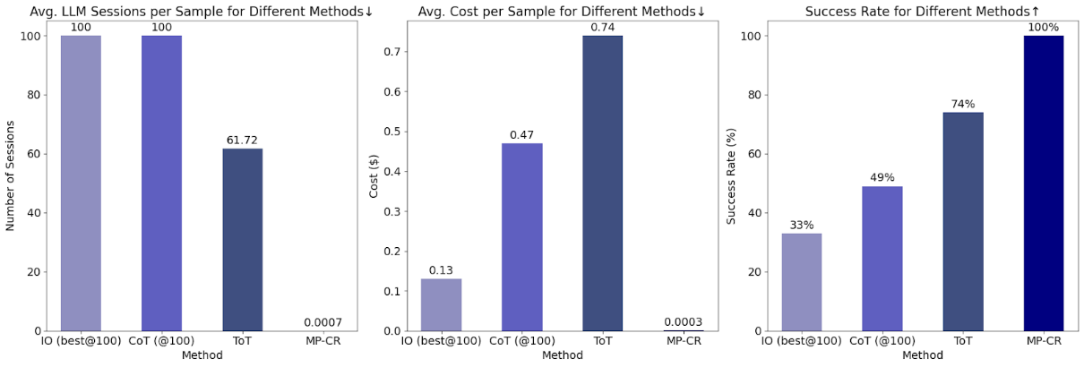
https://github.com/meta-prompting/meta-prompting/blob/main/images/plot3.png
MP research has been conducted by Tsinghua University, Institute for Interdisciplinary Information Sciences (IIIS), Shanghai Artificial Intelligence Laboratory, and Shanghai Qizhi Institute. Their results showed that meta prompting have the fewest average LLM sessions per sample, average cost per sample, and highest success rate when compared to other methods like chain-of-thought (CoT), tree-of-thought (ToT), and input-output (IO).

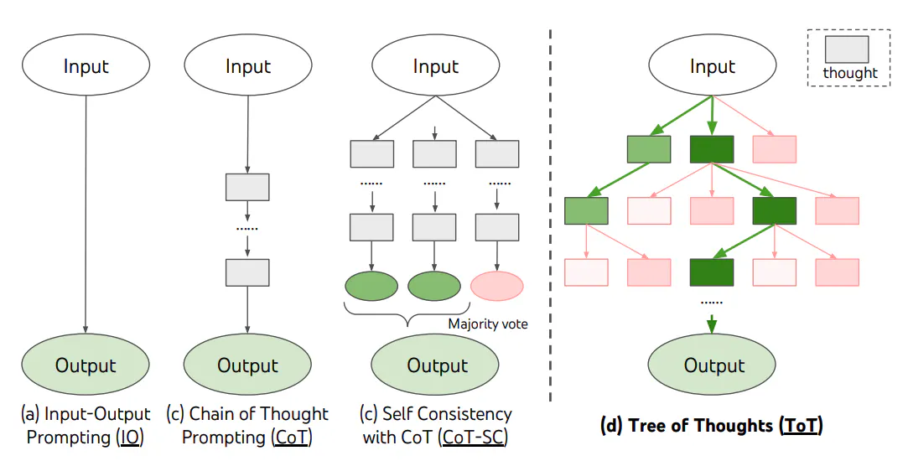
[taken from the prompt engineering guide]
Comparison to Meta Prompting: Meta Prompting (MP) goes beyond both ToT and CoT by focusing on the structure of prompts themselves, enabling recursive prompt generation and deconstructing complex problems into simpler sub-problems, making it more efficient in token use and applicable to a wider range of tasks, including generating new prompts in metaprogramming-like ways. While ToT and CoT are problem-solving techniques, MP enhances the problem-solving process by allowing LMs to dynamically create and optimize the prompts themselves.

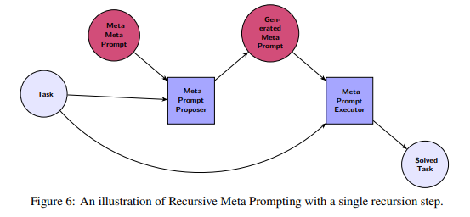
[taken from research abstract]

Key Elements of Meta Prompting in Complex Reasoning

Breaking Down the Problem: We start by dividing a complex problem into smaller, easier tasks that are simpler to solve.
Setting the Stage: We provide all the background information, key concepts, and ideas needed before solving the problem.
Step-by-Step Approach:
- We ask specific questions to guide us through the problem-solving process.
- We sketch out potential answers and test them to see what works.
- We then refine these ideas and provide detailed answers for each step.
Presenting the Final Solution:
- We bring together all the findings to form the complete solution.
- We use coding or other methods to verify the solution.
- Finally, we present the answer in a clear and understandable way.

Illustration of Meta Prompting for Complex Reasoning
Problem: What is the area of a circle with a radius of 7 units?
Solution: Let’s solve this problem step by step.

Preliminary Contents:
- Formula for area of a circle: The area is given by the formula A=πr²
- Given information: The radius of the circle is 7 units.

Hints:
- Hint 1: Use the formula A = πr² with r=7
- Hint 2: Calculate the value of 7² to find r²

Intermediate Steps:
Question 1: What is the value of r² when r=7?
- Answer Sketch: Since r = 7, we calculate r² = 7²
Code for Question 1:
python
r = 7
r_squared = r ** 2
r_squared

Answer for Question 1:
- Answer: r² = 49

Question 2: What is the area of the circle using A=πr2A = \pi r^2A=πr2?
- Answer Sketch: We substitute r² = 49 into the formula for the area.
Code for Question 2:
Python

import math
area = math.pi * r_squared
area

Answer for Question 2:
- Answer: The area of the circle is approximately 153.94 square units.

Final Solution:
Problem restated: What is the area of a circle with a radius of 7?
- Solution Sketch: Using the formula A=πr² and r = 7, we find r² = 49, and then calculate the area.
Code for Final Solution:
python
# Final calculation of the area
area = math.pi * 49
area

Final Answer:
- The answer is 153.94 square units.

Multi-Modal Meta Prompting Situations
Multi-modal situations involve the use of multiple forms of media or input types, such as text, images (e.g., PNG, JPG), audio (e.g., MP3), and video (e.g., MP4), within prompts or interactions. This allows for richer, more diverse inputs and outputs, enabling AI systems to process and respond to various types of data simultaneously.

This is a core struggle for Meta prompting due to its trouble with synchronizing data from different modes. To address this, different modes must have specialized placeholders:
<png_embedding> | Embedded PNG file
<mp3_embedding> | Embedded MP3 audio file
<mp4_embedding> | Embedded MP4 video file
<pdf_embedding> | Embedded PDF file content
<json_embedding> | Embedded JSON structure or data
<xls_embedding> | Embedded Excel spreadsheet data
<py_embedding> | Embedded Python script or code block
<js_embedding> | Embedded JavaScript code block

Of course, they are many more specialized placeholders. You can find them…

Retrieval Augmented Generation (RAG)
Researchers at Meta introduced a method called Retrieval Augmented Generation (RAG) to address the problem of models failing to do knowledge intensive tasks.
This was not an issue when it came to LLMs doing common tasks such as sentiment analysis and responding to basic prompts such as “help me program my app in Python”.
For more knowledge-intensive tasks, it is possible to enable a language model to access external knowledge sources to complete them. This ensures the responses are more factual and reliable which reduces the number of “hallucinations”.
A “hallucination” is when a language model produces outputs that are coherent and free of grammatical errors but factually incorrect or illogical.
For example, if you were to ask a LLM what kind of stocks should I invest in, it would likely not give your a factually accurate response. Do not trade with advice from AI! At least not for now…
How RAG works?
RAG takes an input and then retrieves documents (e.g. an encyclopedia) and produces a final response to the user. This makes RAG a suitable solution for situations which involve facts that can change over time.
RAG involves an LLM retrieving data from a vector database to help answer a question.
Key Principle
Vectored database: a mathematical representation of structured or unstructured data

Concerns with RAG
Many businesses and individuals are concerned with RAG and its potential to produce hallucinations and inaccurate results. RAG follows a simple philosophy: “garbage in, garbage out”.
We must ensure that good and clean data is coming into our database. In addition, data governance and management is done properly too.

Automatic reasoning and Tool-use (ART)
Automatic reasoning and Tool-use (ART) is a new framework which enhances large language models (LLMs) by combining multistep reasoning and external tool integration in an automated and flexible way. The end goal is to improve the model’s ability to tackle complex problems using both chain of thought (CoT) method and use of external tools such as calculators or APIs.
Chain of thought (CoT) helps the model decompose the logical steps and external tools help enhance the response of the model.
How ART works
Similar to the previous prompting methods, the model first begins generating a response and reason using its previous knowledge.

Generation and Tool Integration: During the reasoning process, ART automatically pauses the LLM’s generation whenever an external tool is needed. It then calls the required tool (e.g., for computations, retrievals, or external API requests), integrates the output, and resumes the reasoning steps.

Zero-Shot Generalization: ART is designed to generalize to new, unseen tasks without requiring hand-crafted demonstrations. By using the task and tool libraries, ART helps the model decompose new problems and apply appropriate tools where necessary, thus making it robust for tasks that it hasn't explicitly encountered before.

Extensibility and Human Feedback: One of ART’s strengths is its extensibility. Humans can update the task library, fix mistakes in the LLM’s reasoning, or add new tools. This allows for continuous improvement of the model’s performance and adaptability to evolving tasks.

Key Advantages of ART
ART outperforms traditional few-shot or zero shot prompting and automatic CoT approaches. For example, in complex tasks which require new information or complex computation, ART is a much more powerful framework. It specialized in reasoning-heavy, multi-step problems which require precision and external help.
Automated Task Decomposition: It breaks down tasks dynamically without needing hand-crafted solutions for each new problem.
Tool Integration: Pauses reasoning when external computation or information retrieval is needed, leading to more accurate task completion.
Extensible Framework: Humans can update the model’s reasoning processes and tool libraries, allowing for adaptability and improved performance over time.

Directional Stimulus Prompting
Directional Stimulus Prompting (DSP) is an innovative framework to guide LLMs towards more effective and desired outputs without the need to fine-tune them.
Fine-tuning, in essence, means taking a pre-trained model (e.g. GPT-2) and adjusting it to better fit your data or desired task.
- Stimulus: This is a cue or signal that triggers a response. It can be a verbal prompt, a gesture, a visual aid, or even an environmental change.
- Direction: The term "directional" refers to guiding the individual toward a specific behavior or outcome. For example, if a teacher wants a student to raise their hand before speaking, they might point to the hand-raising area as a visual cue.
- Prompting: This is the act of providing guidance or assistance to help the individual understand what behavior is desired. It can range from subtle cues (like a nod) to more explicit instructions (like saying, “Please raise your hand”).
DSP has been evaluated across several tasks, including summarization, dialogue generation, and chain-of-thought reasoning. In experiments:
- On the CNN/Daily Mail dataset for summarization, DSP showed a noticeable improvement in performance (e.g., ROUGE scores) over standard prompting techniques.
- In dialogue tasks like MultiWOZ, using just 80 samples, DSP increased ChatGPT’s performance by over 40%, exceeding even some fully-supervised models.

Check your knowledge
- Question 1
- Question 2
- Question 3
- Question 4
- Question 5

3
Answers
- Question 1
- Question 2
- Question 3
- Question 4
- Question 5

Running Ollama: CLI, API, and Fine-Tuning for Beginners and Experts
If you haven’t downloaded Ollama, please refer to the previous chapter.
You will need:
- At least 8 GB of RAM available to run 7B models
- At least 16 GB of RAM to run 13B models
- At least 32 GB of RAM to run 33B models

Running LLMs with Command Line Interface (CLI):
One method to run Ollama is to use the command line interface (CLI)

A command line interface (CLI) is a mechanism that enables a human to operating system interaction.

Running your first models on Ollama
Run to chat with a language model using the following command:

ollama run <model-name>

This table covers the most common models that can be used with Ollama:

Model | Parameters | Size | Download
Llama 3.2 | 3B | 2.0GB | ollama run llama3.2
Llama 3.2 | 1B | 1.3GB | ollama run llama3.2:1b
Llama 3.1 | 8B | 4.7GB | ollama run llama3.1
Llama 3.1 | 70B | 40GB | ollama run llama3.1:70b
Llama 3.1 | 405B | 231GB | ollama run llama3.1:405b
Phi 3 Mini | 3.8B | 2.3GB | ollama run phi3
Phi 3 Medium | 14B | 7.9GB | ollama run phi3:medium
Gemma 2 | 2B | 1.6GB | ollama run gemma2:2b
Gemma 2 | 9B | 5.5GB | ollama run gemma2
Gemma 2 | 27B | 16GB | ollama run gemma2:27b
Mistral | 7B | 4.1GB | ollama run mistral
Moondream 2 | 1.4B | 829MB | ollama run moondream
Neural Chat | 7B | 4.1GB | ollama run neural-chat
Starling | 7B | 4.1GB | ollama run starling-lm
Code Llama | 7B | 3.8GB | ollama run codellama
Llama 2 Uncensored | 7B | 3.8GB | ollama run llama2-uncensored
LLaVA | 7B | 4.5GB | ollama run llava
Solar | 10.7B | 6.1GB | ollama run solar
Key CLI Commands:
- Serving Ollama: starts Ollama
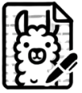
ollama serve

- Run a model: runs a model in your local environment.
ollama run <model-name>
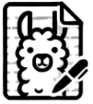
ollama run <model-name>

E.g. ollama run llama3

- Stop a model: stops the execution of a model in your local environment.

ollama stop <model-name>

E.g. ollama stop llama3

- Pulling a model: fetches the model to your local environment, ensuring its available offline for future use
ollama pull <model-name>
ollama pull <model-name>

E.g. ollama pull gpt-3.5
- Creating a model: creates a new model using customized model file
ollama create new-phi --file new.modelfile

- Listing available models: shows all the available models in the repository that you can run or customize
ollama list

- List currently loaded models: shows all the models in the repository that are currently loaded or running
ollama ps

- Removing a model: removes a model from your local environment
ollama rm <model-name>

E.g. ollama rm llama3

- Show a model: shows model information in your local environment.
ollama show <model-name>

E.g. ollama show mistral
- Copy a model: copies a model in your local environment. Allows for customization, experimentation, and versioning.
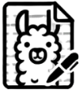
ollama cp <model-name> <your-preffered-model-name>

E.g. ollama cp llama3 my-custom-model-name
Running with Parameters: adjusting parameters and modify the behavior of your model
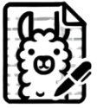
ollama run <model-name> --<argument 1> <value> --<argument 2> <value>

E.g. ollama run gpt-3.5 --temperature 0.7 --max-tokens 300

- Batch Processing via CLI: if you need to process multiple prompts or datasets, you can handle batch inputs through a CLI
ollama run <model-name> --input-file <input-file-name> --output-file <output-file-name>

E.g. ollama run gpt-3.5 --input-file my-prompts.txt --output-file my-responses.txt
For the full list of commands and official documentation please visit the official Ollama website at ollama.com
Check your knowledge
- Question 1
- Question 2
- Question 3
- Question 4
- Question 5

Answer
- Question 1
- Question 2
- Question 3
- Question 4
- Question 5

Running Models with API
Application programming interface (API) is an interface for two application or services to communicate with each other.
For example, the backend of an application is an API which communicates actively with the frontend to operate an application.
Ollama’s API offers more flexibility than the command line interface (CLI).

Setting up the API
Start the Ollama API server. This step is usually done through a CLI by running this command

ollama api –port 8000

The API server will be started on port 8000 by default, but you can adjust the port if needed by specific value:
ollama api –port <port-value>

Basic API Call
Ollama uses a REST API that can be leveraged for running and managing models.
This allows web services, web applications, client applications, or backend systems to use LLMs more easily (e.g. chatbots, automated content generation tools, recommendations engines, etc.)

Generate a Response
curl http://localhost:11434/api/generate -d '{
"model": "llama3.2",
"prompt":"Why is the sky blue?"
}'

Chat with a model
curl http://localhost:11434/api/chat -d '{
"model": "llama3.2",
"messages": [
{ "role": "user", "content": "why is the sky blue?" }
]
}'
Notice how we assigned a role to the model when we prompted it

Ollama API with Popular Frameworks
Ollama API can be used with many other programming languages or frameworks.

Python
import requests
url = "http://localhost:8000/v1/models/gpt-3.5"
data = {
"prompt": "Explain the concept of an large language model (LLM)to a 5-year-old."
}
response = requests.post(url, json=data)
print(response.json())

JavaScript
async function getData() {
const url = "http://localhost:11434/api/generate"; // Ollama API endpoint
const data = {
model: "llama3.2",
prompt: "Explain the concept of an LLM to a 5-year-old."
};
try {
const response = await fetch(url, {
method: "POST",
headers: {
"Content-Type": "application/json",
},
body: JSON.stringify(data),
});
if (!response.ok) {
throw new Error(`Response status: ${response.status}`);
}
const json = await response.json();
console.log(json);
// Handle the response from the model
} catch (error) {
console.error(error.message); // Handle any errors
}

Ollama REST API
Representational State Transfer (REST) is a software architecture that provides a good condition on how an application programming interface (API) should work. It enables developers to develop high-tier applications by supporting a reliable form of communication across the web when done at a large scale.
APIs that operate using the REST architecture are referred to as REST API or, in some cases, RESTful API.
This architecture postulates four constraints:
- Requests should identify resources, typically by using a uniform resource identifier (URI)
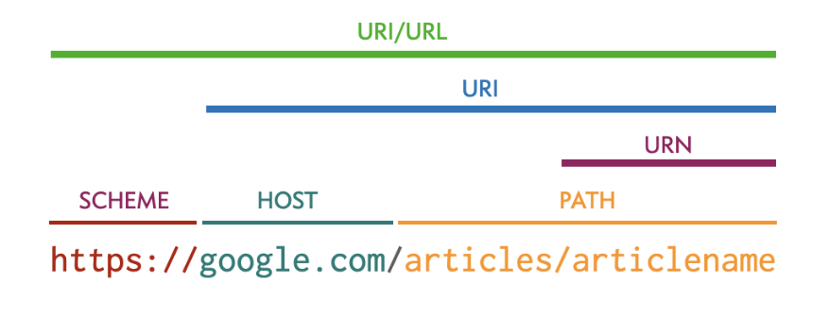
- The client request should provide enough details in the resource’s representation to allow them to be modified, deleted, or created if needed. This is typically done in the form of HTTP methods
- Clients receive guidance on how to handle the resource representation with the server delivering self-descriptive messages containing metadata to help the client(s) use the resource effectively
- Clients should be given links to all related resources necessary for completing a task, enabling them to discover additional resources as needed through hyperlinks provided in the server's response.

The key characteristics of REST are as follows:
- Statelessness: In REST, each client request is handled independently, free from the influence of other incoming requests. This ensures the server can fully understand and fulfill each request on its own.
- Layered System: REST allows clients to interact with intermediary layers between themselves and the server, ensuring requests can be routed and processed through multiple servers without client awareness
- Cacheability: REST APIs can improve efficiency by defining which responses are cacheable, enabling clients or intermediaries to store responses and reuse them without contacting the server again.
- On-Demand Code: REST framework sends code to clients temporarily, allowing clients to function dynamically and perform vital tasks like validating form data directly from the code the server provides.

Ollama REST supports these functionalities:
- Generating a completion - generating a response to a given prompt
- Generate a chat completion
- Create a model
- List local models
- Show model information
- Copy a model
- Delete a model
- Pull a model
- Push a model
- Generate Embeddings
- List Running Models
Covering all of these topics in depth would require almost another book. Therefore, if you are a developer and you want to read the full documentation, please head over to https://github.com/ollama/ollama/blob/main/docs/api.md

Running Customized Models
More often that not, you will need to customize models. This allows you to fine-tune the behavior of a model without having to train it from scratch. Adjusting the parameters or prompts of a model can make a model more effective for your desired use case.

Why Customize a Model?
- Allow you to add domain-specific knowledge, making it more efficient to industry-specific language or jargon
- Optimize performance by modifying parameters to make models more accurate or efficient for a specific task

Modelfiles allow users to define the behavior and properties of a model:
{
"model": "gpt-3.5",
"customizations": {
"system_message": "You are a helpful assistant specialized in finance and accounting.",
"temperature": 0.6,
"top_p": 0.9
}
}

Key Principle: Hyperparameters
These hyperparameters can be adjusted to suit your customized model:
Context Window: the amount of text (context) a model takes into consideration when generating a response
Max Tokens: the maximum number of tokens in generated responses. Tokens can be individuals untis of text (e.g. words or characters). For example, if you set the max tokens to 100, the model will generate a response containing a maximum of 100 tokens.
Temperature: a hyperparameter that determines the creativeness, variability, or randomness of an AI’s output/response. For example, a temperature of 1.0 leads to more randomness and diversity. On the other hand, a lower temperature value, like 0.2, produces more focused and rigid responses
Top-p: controls how much the probability distribution to consider when generating a response. For example, it
Top-n: limits the number of choices the model considers when generating a response, selecting from the top n most likely options, regardless of the combined probability. For example, it could only consider the top 10 possibilities
Presence Penalty: reduces the model’s tendency to repeat words or phrases by penalizing words that have already appeared in the conversation, encouraging the model to introduce new ideas and content.
Frequency Penalty: controls how often certain words or tokens can appear in a response. A higher frequency penalty discourages the model from using the same word repeatedly, promoting more diverse word choice.

Running your customized models
To run your customized model, use:
ollama run —-config modelfile.json

Running Fine-tuned Models
Fine-tuning goes beyond customization. It allows you to train a model with your specific data, ensuring its response is linked even more closely to your domain or task.
It requires specialized datasets and a bit of computing power. However, it enhances the relevance and accuracy of the model’s outputs.
Similar to model customization, it enables models to perform better for niche use cases (e.g. healthcare, legal documentation, or technical support in any other field). In addition, it supports data-specific learning as it can pick up patterns and terminology specific to you domain, thus making it more effective.

Fine-Tuning with Ollama
Ollama supports fine-tuning pre-trained models (e.g. GPT-3.5, Llama 3.2, etc) by adding domain-specific data.
Prepare the Dataset: Collect and clean text data representative of the responses you want the model to generate.
Run the Fine-Tuning Command in CLI: Use the following command to fine-tune a pre-trained model:
ollama fine-tune --model gpt-3.5 --data your-dataset.json

Evaluate the Fine-Tuned Model: After fine-tuning, it’s essential to evaluate the model to ensure it performs well on your task. You can use validation datasets and compare the model's performance before and after fine-tuning.

Ollama SDK?

